Day 26: 20-11-2025:
CI and CD tools:
Continuous integration Continuous delivery or deployment

Dev1 login page

Dev2 Shared Organization
business logic Repository CI/CD tools
Dev3 pull code and re-build it
Database tables and query whenever any changs
Happen in SCM ie github These CI and CD tools pull it and re-build. If it success it pass this code to other team. If fail then can send the notification to respective team members.

Jenkin is a type of an open source CI/CD tool. It is base upon Java technologies. Jenkin is GUI base as well as plugin base CI and CD tools.

Download Jenkin war file using below website

https://www.jenkins.io/download/

after downloaded war file open the command prompt and run below command as
java -jar jenkins.war

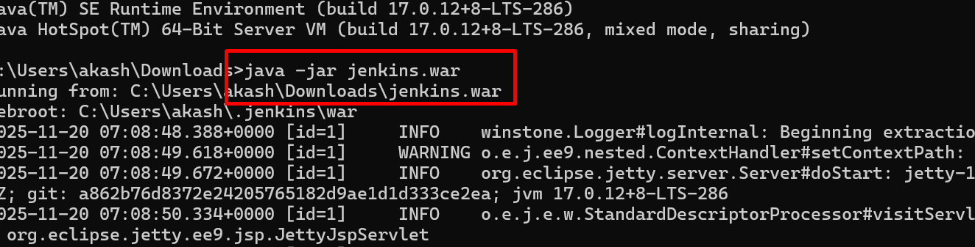

Open the browser then write the URL as

http://localhost:8080
it ask you admin password. Initial password display on console. Copy and paste that password.

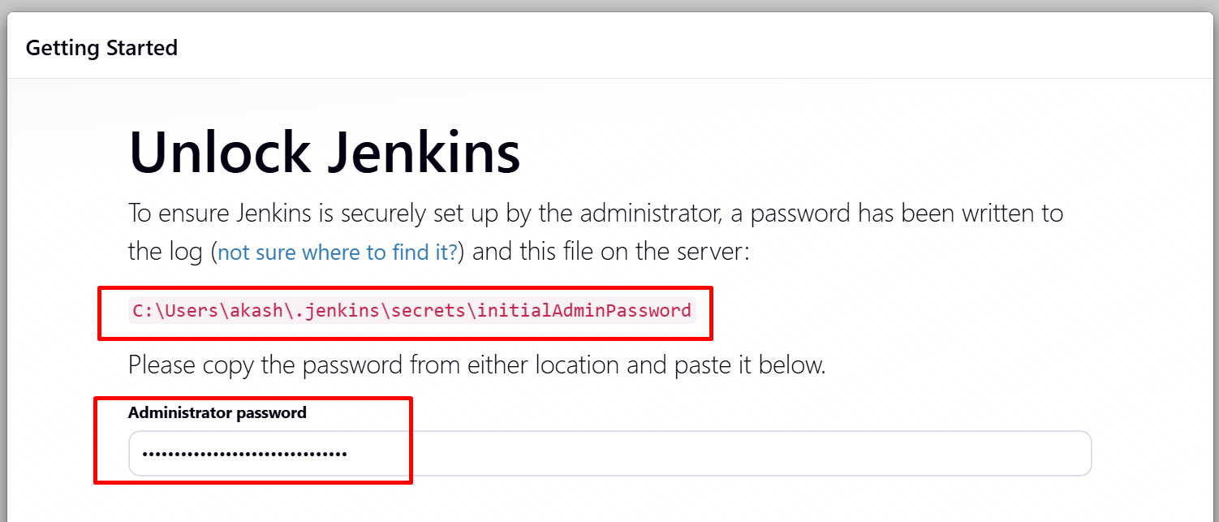

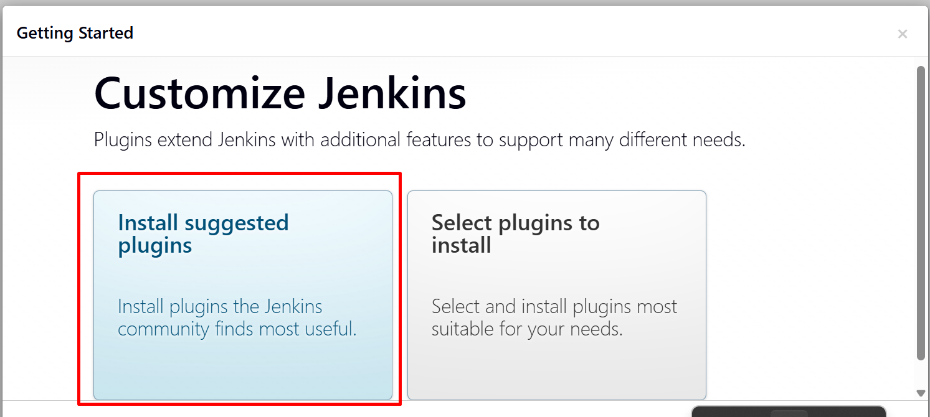

Creating job to pull Java Project

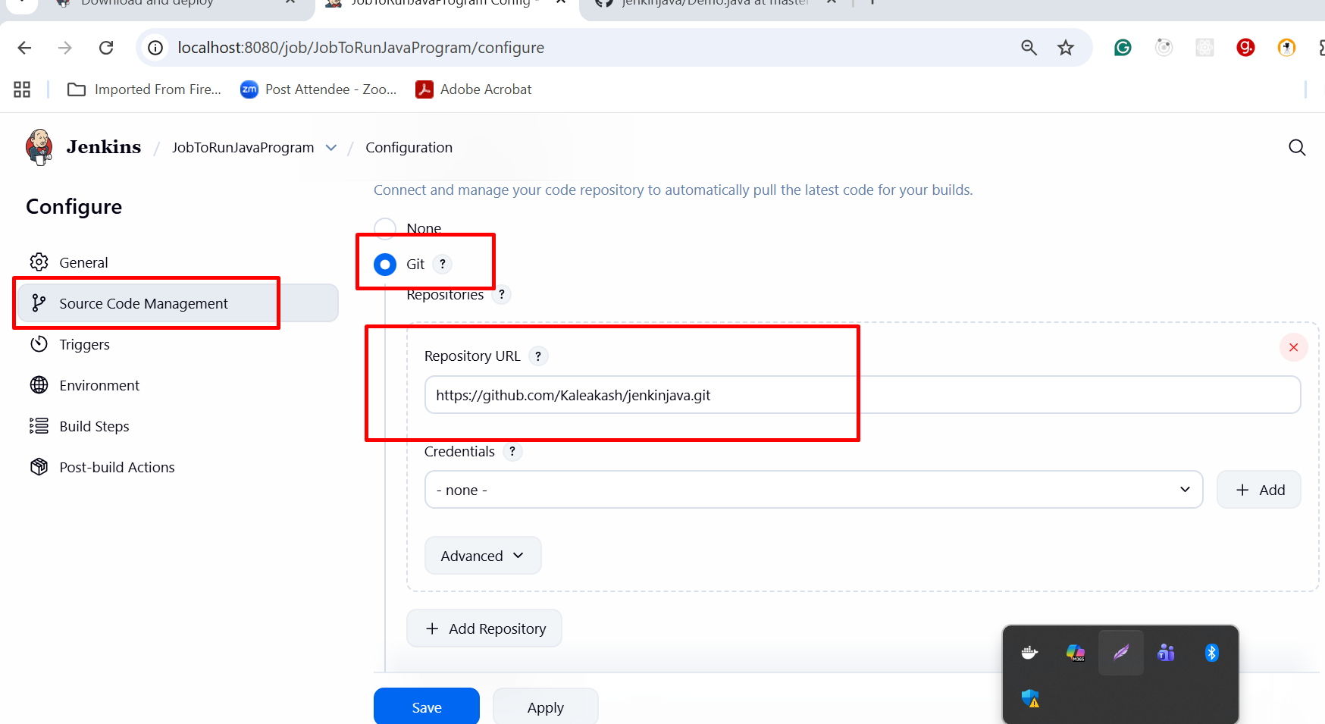

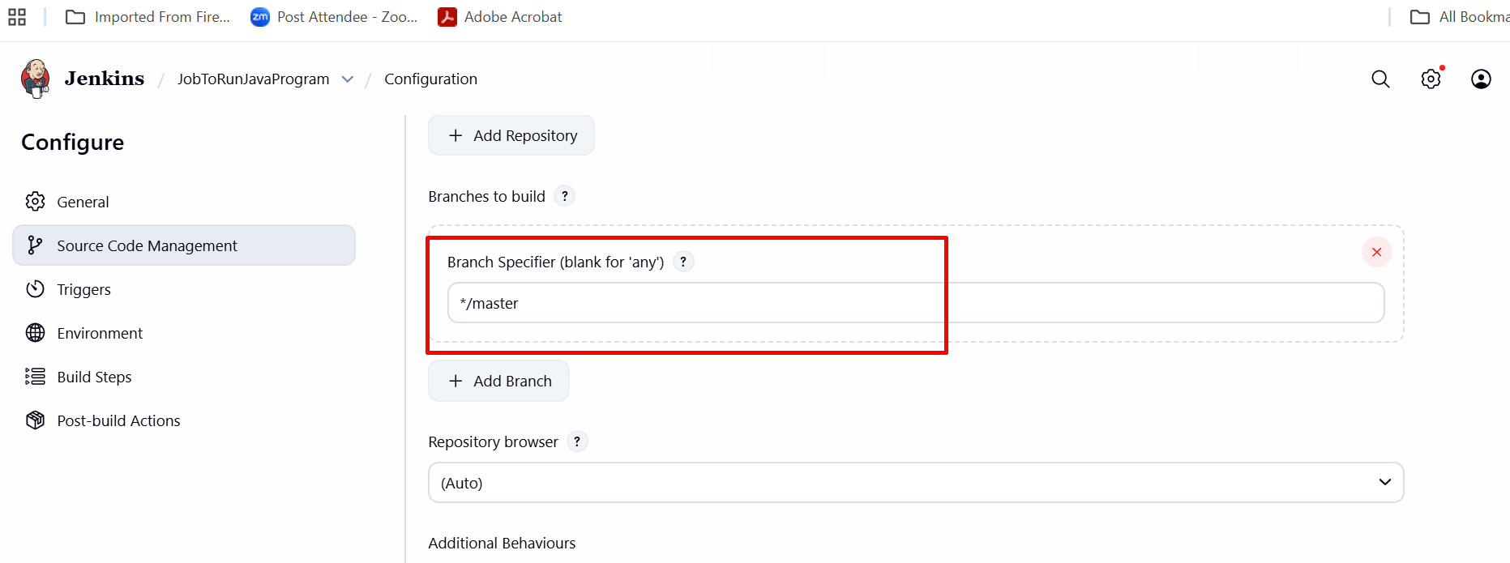

Build the project with trigger option

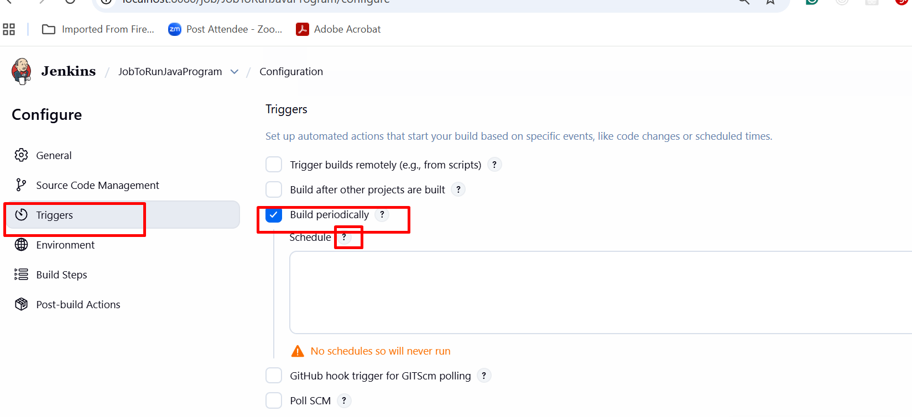

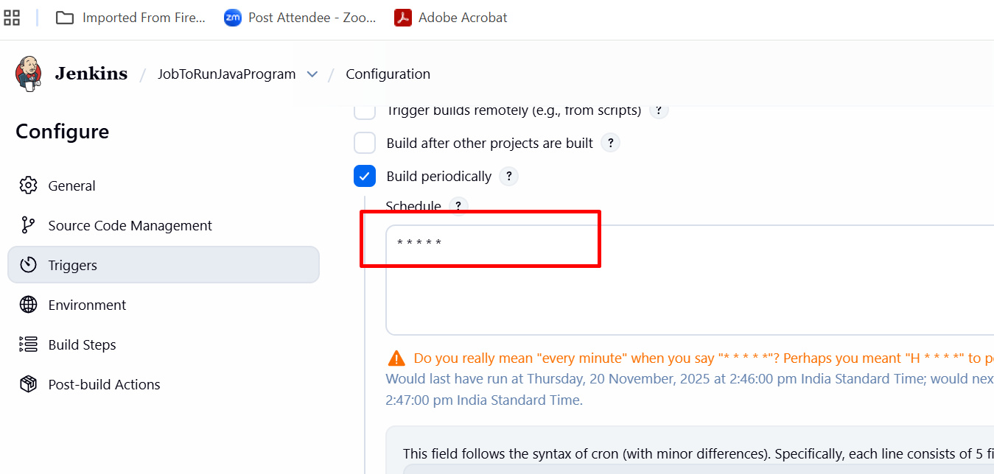

Creating Jenkin Job with Trigger features to build the project whenever owner push the code in remote repository.

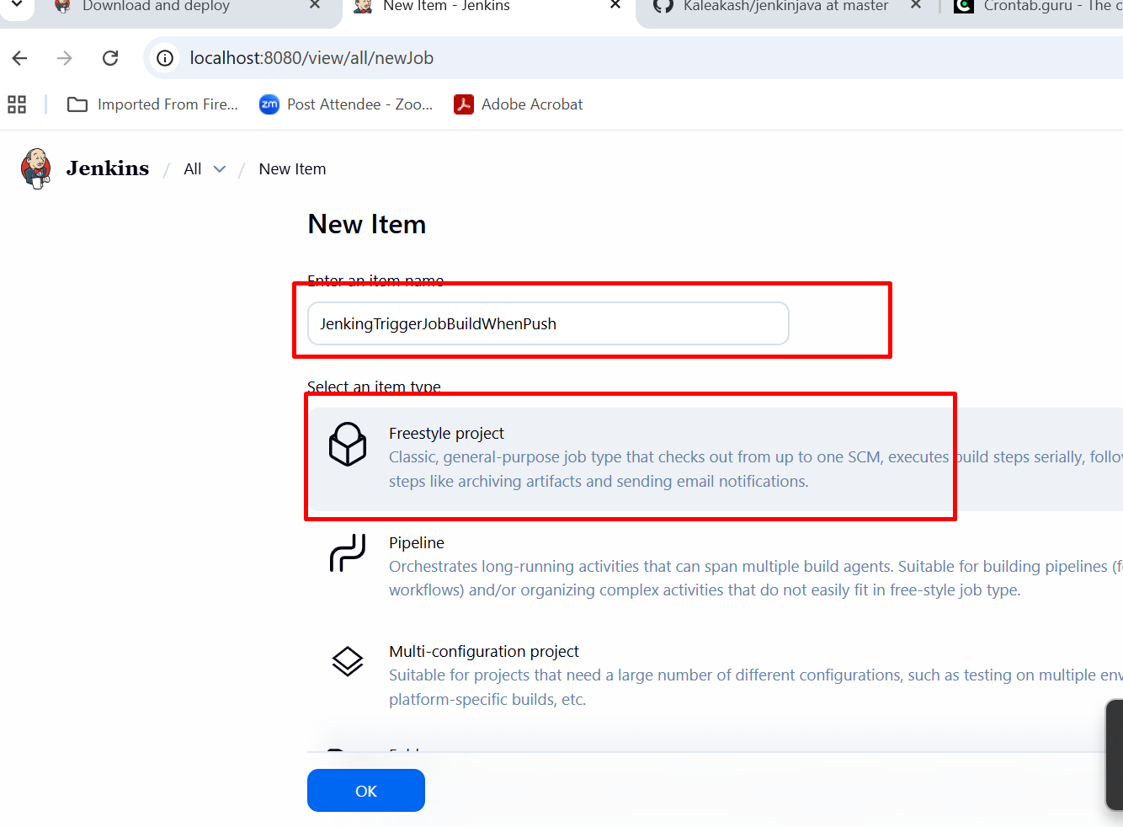

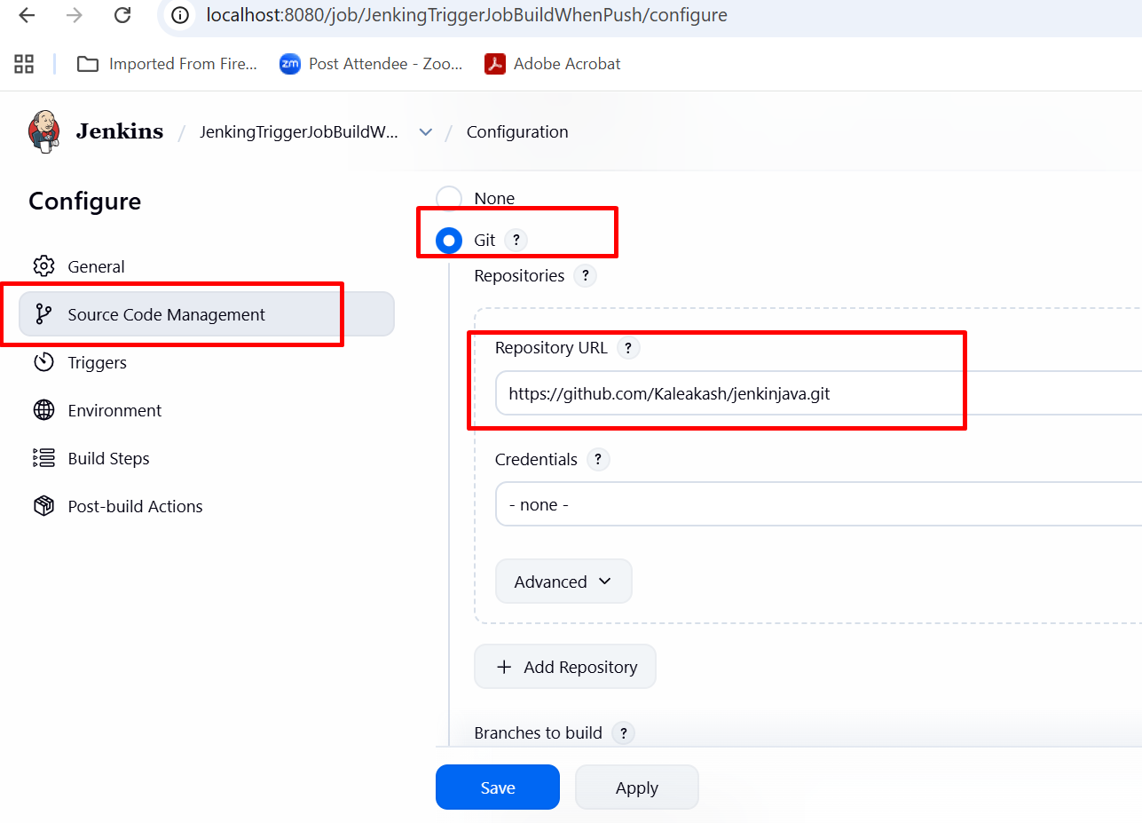

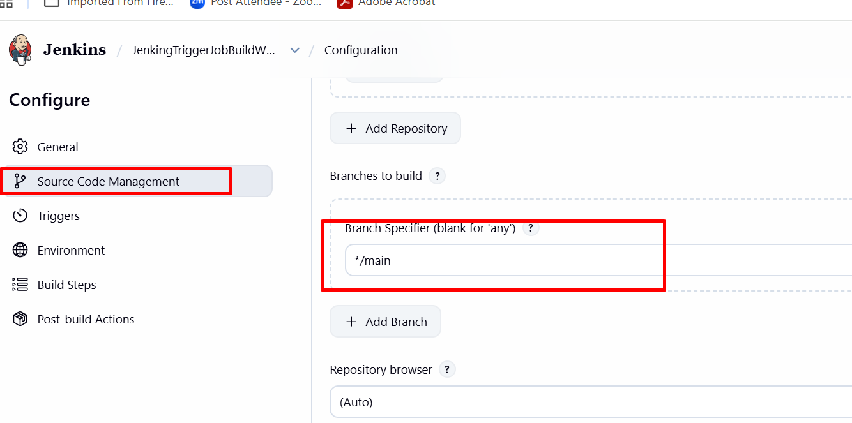

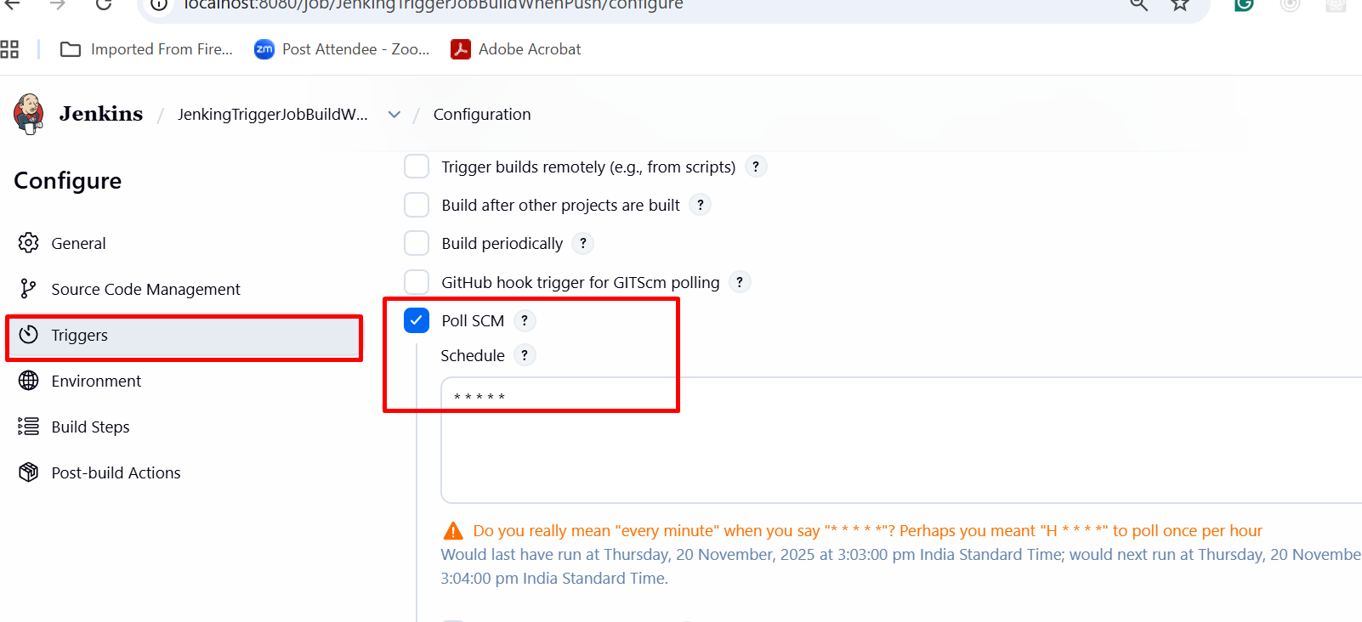

It check every minutes in remote repository. If any changes happen then only build else no build.

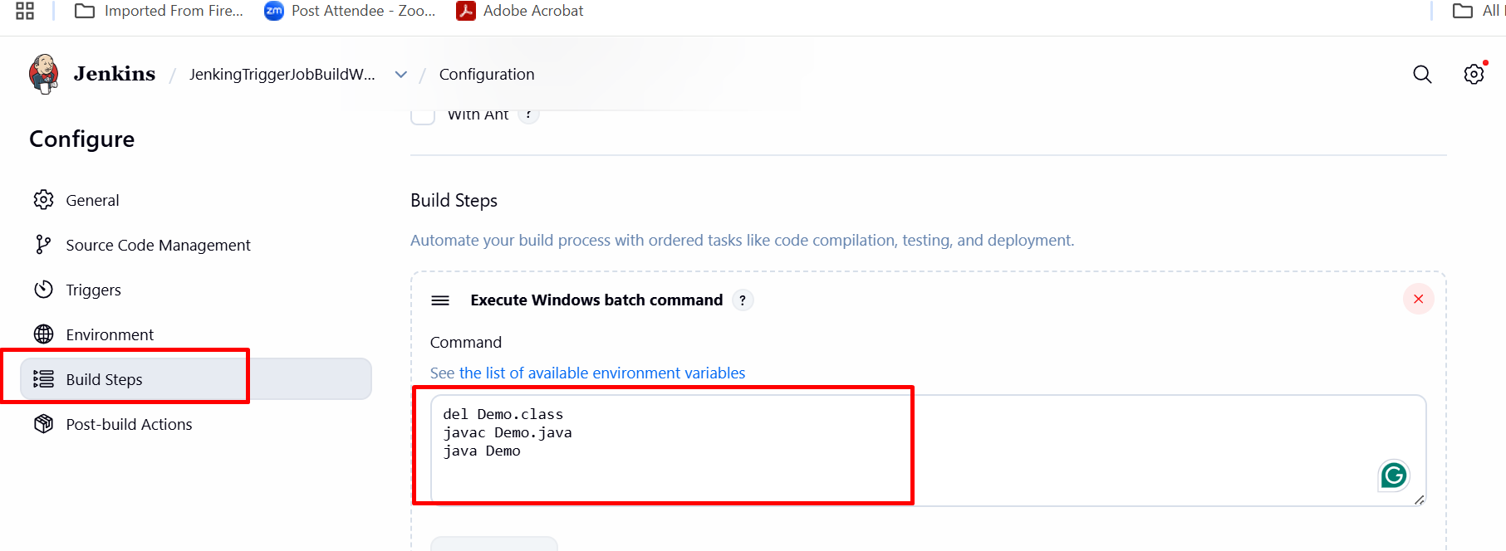

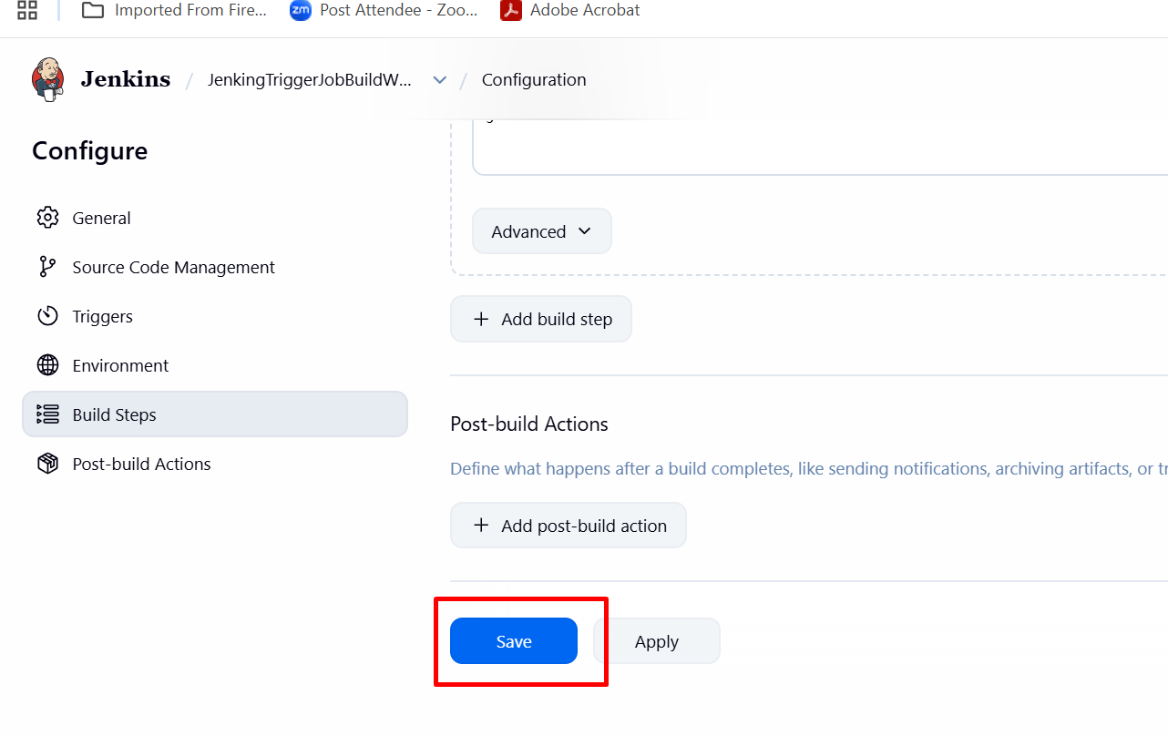

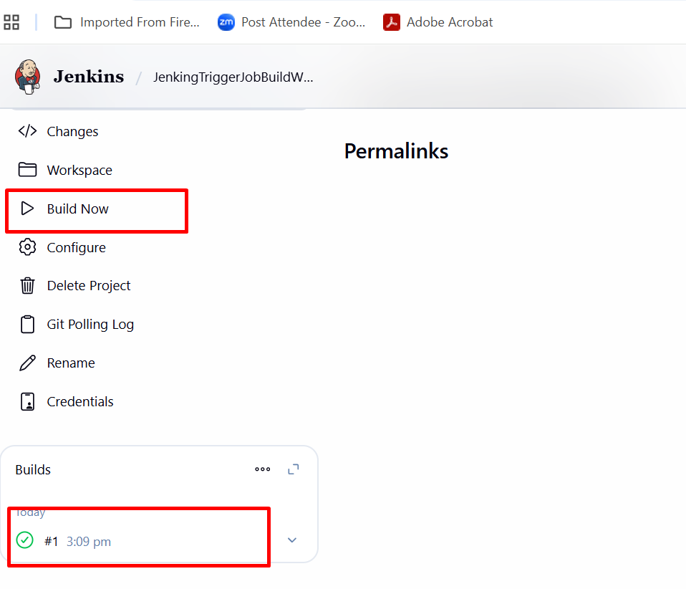

Job to build spring boot project using maven build tool

In build option

